# **CHAPTER ONE**

INTRODUCTION

## **1.1 Background of Study**

Lung cancer remains a leading cause of cancer-related mortality worldwide, representing a significant public health challenge. In the United States alone, lung cancer is the second most prevalent cancer type among both men and women, exceeded only by prostate and breast cancers respectively. The vast majority of lung cancers are classified into two main histological categories: non-small cell lung cancer (NSCLC) accounting for approximately 84% of cases, and small cell lung cancer (SCLC) comprising around 13%. This histological distinction is crucial for guiding appropriate treatment strategies [1].

The primary risk factor for lung cancer is smoking, which is closely linked to 80-90% of lung cancer deaths. However, exposure to radon gas is also a notable cause of lung cancer among non-smokers. Given the tremendous burden of lung cancer morbidity and mortality, numerous clinical practice guidelines have been developed with the aim of improving patient outcomes through standardized evidence-based management.

Early detection remains the key to improving long-term survival for lung cancer patients. When diagnosed at an early stage, lung cancer is more amenable to potentially curative treatment approaches such as surgery, radiation therapy, or combined modality treatment. However, lung cancers often remain asymptomatic until they have reached an advanced stage, presenting a significant barrier to timely diagnosis and intervention.

Imaging techniques such as chest X-rays and computed tomography (CT) scans play a vital role in lung cancer screening and diagnosis. The National Lung Screening Trial demonstrated that low-dose CT screening in high-risk individuals can reduce lung cancer mortality by approximately 20% compared to chest X-ray screening. However, the interpretation of radiological images is a challenging and subjective process, with substantial variability even among experienced radiologists [2].

In this project, the application of artificial intelligence (AI) and Deep learning (ML) techniques for automated lung cancer detection and classification from radiological images has garnered significant research interest. By leveraging the powerful pattern recognition capabilities of Convolutional Neural Network, these approaches aim to improve the accuracy, consistency, and efficiency of lung cancer diagnosis from imaging data.

Numerous studies have explored the use of AI/ML models for lung cancer detection and classification tasks, employing various techniques such as convolutional neural networks (CNNs), support vector machines (SVMs), and ensemble methods. These models are trained on large datasets of radiological images, some of which are annotated with lesion locations and histological subtypes by expert radiologists [3].

The integration of AI/ML tools into clinical workflows has the potential to enhance radiologists' performance by providing decision support, reducing diagnostic errors, and improving workflow efficiency. However, translating these research efforts into clinically validated and widely adopted tools requires rigorous validation, regulatory approval, and effective integration into existing healthcare systems.

This paper aims to provide a comprehensive review of the current state-of-the-art in AI/ML approaches for lung cancer detection and classification from radiological images. It will critically analyse different related methodologies, highlight key challenges and obstacles to clinical translation, and discuss potential strategies to overcome these barriers. By synthesizing the latest research in this rapidly evolving field, this project seeks to inform and guide future efforts towards developing robust and impactful AI/ML solutions for improving lung cancer diagnosis and management [4].

## **1.2 Significance of Study**

Early detection is paramount for improving lung cancer outcomes, as it vastly increases the chances of successful treatment and long-term survival. However, lung cancers often remain asymptomatic until later stages, when they become more difficult to treat effectively. This underscores the critical importance of screening and early diagnosis efforts.

The application of artificial intelligence techniques for automated lung cancer detection from radiological imaging data holds immense potential for enabling more effective and widespread early detection programs. By accurately identifying subtle radiological abnormalities associated with early-stage lung cancer, artificial intelligence systems could allow for earlier diagnosis and intervention compared to current clinical practice standards [5].

Critically, artificial intelligence models can learn to recognize incredibly complex patterns in imaging data that may not be readily apparent to human observers. Their ability to integrate numerous distinct features and biomarkers could potentially enhance the sensitivity of lung cancer detection beyond what an individual radiologist can achieve through visual inspection alone.

Furthermore, artificial intelligence systems offer increased consistency and reproducibility compared to manual interpretation. Even experienced radiologists can suffer from fatigue, distraction, or cognitive biases that impact their diagnostic performance. Automated artificial intelligence systems are not susceptible to such human factors and can maintain a consistent level of accuracy across large imaging volumes [6].

Widespread implementation of validated artificial intelligence models for lung cancer screening could enable truly population-scale early detection efforts that are simply not feasible with current radiologist-dependent workflows. These artificial intelligence tools could be seamlessly integrated into existing clinical pipelines, automatically triaging cases that warrant further investigation by radiologists.

By facilitating earlier lung cancer diagnosis, artificial intelligence systems may reduce lung cancer mortality rates by enabling timely intervention when tumors are most amenable to curative treatment modalities like surgery. Conversely, late-stage detection often necessitates more aggressive systemic therapies with significant side effects and diminished efficacy.

In addition to the immense clinical benefits, widespread early lung cancer detection facilitated by artificial intelligence could also yield considerable economic benefits by reducing downstream costs associated with treating advanced cancers that require extensive hospitalization and palliative care.

## **1.3 Statement of the problem**

Lung cancer is the leading cause of cancer-related mortality worldwide, yet most cases are not detected until advanced stages when treatment options are limited. Current radiological methods like CT scans for lung cancer detection rely heavily on subjective human interpretation by radiologists, leading to potential errors, inconsistencies, and delays in diagnosis. Existing screening programs also suffer from high false positive rates and lack of scalability [7].

There is an urgent need for accurate, robust and scalable solutions to enable reliable early lung cancer detection at a population level. Artificial intelligence techniques applied to radiological image analysis show great promise in this domain but face significant challenges in meeting the performance and clinical standards required for widespread adoption. Overcoming these hurdles is critical for facilitating timely lung cancer diagnosis and intervention to improve outcomes and survival.

This paper aims to evaluate the current state and key challenges of using artificial intelligence for automated, accurate and scalable lung cancer detection from medical imaging data to ultimately reduce diagnostic errors and delays.

## **1.4 Aims and Objectives**

### **1.4.1 Aims**

The aim of this project is to develop a Deep learning model for detection of Lung cancer from CT scan images.

### **1.4.2 Objectives**

At the end of the work the following will be achieved:

1. Collect and preprocess a diverse dataset of lung CT scans
2. Design and develop a CNN architecture suitable for lung cancer detection.
3. Train and validate the CNN model using the collected dataset.
4. Evaluate the model's performance using appropriate metrics.
5. Provide a user-friendly interface for inference and visualization of results.

## **1.5 Methodology**

The methodology implemented in this study involves a systematic approach to dataset collection, analysis, and evaluation using a Convolutional Neural Network Model. The steps involved in the methodology include;

**1. Data Collection:** The primary requirement for developing effective artificial intelligence models for lung cancer detection is access to large, diverse datasets of radiological images. These datasets ideally consist of chest X-rays, CT scans, or other relevant medical imaging modalities, along with corresponding labels indicating the presence, location, and type of lung cancer (if any).

**2. Data Preprocessing:** Once the imaging data is collected, several preprocessing steps are necessary to prepare the data for model training. These include image resizing, normalization, augmentation (e.g., rotation, flipping, zooming) to increase the diversity of the training data, and techniques to handle class imbalances or missing data.

**3. Model Selection:** The choice of the specific artificial intelligence model architecture is a critical step in the methodology. Deep learning models, particularly convolutional neural networks (CNNs), have shown excellent performance in various medical image analysis tasks, including lung cancer detection.

**4. Model Training, Evaluation, and Metrics:** Once the model architecture is chosen, the next step involves training the model using the preprocessed imaging data and ground truth labels. This typically involves splitting the dataset into training, validation, and test sets, and using techniques like transfer learning, data augmentation, and hyperparameter tuning to optimize model performance. During the training process, appropriate evaluation metrics will be defined and monitored, such as sensitivity (true positive rate), specificity (true negative rate), precision, recall, F1-score, etc. These metrics help assess the model's ability to accurately detect lung cancers while minimizing false positives and false negatives.

**5. Model Deployment and Integration:** After developing and evaluating the artificial intelligence model, the final step involves deploying and integrating the model into clinical workflows and decision support systems. This may involve creating user-friendly interfaces, such as web applications or software tools, that allow radiologists or healthcare professionals to upload medical images and receive predictions from the trained model.

## **1.6 Scope of Study**

This project aims to develop an efficient convolutional neural network (CNN) based system for accurate detection and classification of lung cancer from available medical imaging datasets. The primary focus will be on demonstrating the proof of concept and technical feasibility of using deep learning models for this application, rather than immediate clinical deployment.

Specifically, the study will involve exploring and evaluating different CNN architectures and training strategies to achieve high performance in identifying the presence, location, and histological subtype of lung cancers within radiological images such as chest X-rays or CT scans. Various data preprocessing techniques, model optimization methods, and evaluation metrics will be explored to develop a robust and generalizable lung cancer detection system.

## **1.7 Project Organization**

The rest of this project report is organized as follows:

**Chapter 2: Literature Review**

- Provides a historical overview of the development of lung cancer detection systems

- Critical evaluation of previous and relevant research in this field

**Chapter 3: Methodology**

- Discusses the approach and methodology used to accomplish the project's goals and objectives

**Chapter 4: Results and Discussion**

- Presents and analyses the results obtained from the developed CNN-based lung cancer detection system

**Chapter 5: Conclusions and Future Work**

- Summarizes the project's conclusions and key findings

- Discusses implementation considerations and challenges

- Explores the future directions and potential advancements in lung cancer detection using artificial intelligence

# **CHAPTER TWO**

LITERATURE REVIEW

## **2.1 Introduction**

In recent years, the rapid advancement of artificial intelligence (AI), particularly deep learning techniques, has opened new avenues for automating and enhancing the process of lung cancer detection from radiological images. Leveraging the powerful pattern recognition capabilities of deep neural networks, these AI-based approaches aim to provide accurate, consistent, and scalable solutions for identifying lung cancers, potentially overcoming the limitations of human interpretation.

This literature review aims to provide a comprehensive overview of the current state-of-the-art in applying artificial intelligence for lung cancer detection and classification from medical imaging data. It will critically examine and synthesize the findings from relevant research studies, highlighting the various methodologies, datasets, model architectures, and evaluation metrics employed in this domain.

### **2.1.1 Lung Cancer Diagnosis**

Lung cancer remains one of the most lethal and prevalent forms of cancer globally, accounting for a significant portion of cancer-related deaths worldwide. Early detection and accurate diagnosis are crucial for improving patient outcomes and survival rates. Computed Tomography (CT) scans have emerged as a powerful diagnostic tool for lung cancer screening and detection, offering high-resolution three-dimensional images of the lungs and surrounding structures.

CT scans play a vital role in the early detection of lung cancer, as they can reveal small nodules or lesions that may not be visible on traditional chest X-rays. The high-resolution images provided by CT scans enable radiologists to identify and characterize these abnormalities, which can be the first indicators of lung cancer. Early detection through CT screening has been shown to improve patient survival rates significantly, as it allows for timely intervention and treatment when the cancer is still at an early and potentially curable stage [8].

In addition to lung cancer screening, CT scans are also essential for diagnosis, staging, and treatment planning. Once a suspicious nodule or lesion is identified, further diagnostic CT scans can provide detailed information about the size, shape, and location of the tumor, as well as its relationship to surrounding tissues and structures. This information is crucial for determining the stage of cancer, which guides the appropriate treatment approach, such as surgery, radiation therapy, chemotherapy, or a combination of these modalities.

CT scans offer several advantages over other imaging techniques in lung cancer diagnosis. They provide high-resolution, cross-sectional images that can accurately depict the extent and spread of the tumor, as well as any involvement of nearby lymph nodes or metastases to other organs. Additionally, CT scans can be combined with other imaging modalities, such as Positron Emission Tomography (PET), to create PET-CT scans, which provide both anatomical and functional information about the tumor [1], [3].

Despite the significant benefits of CT scans in lung cancer diagnosis, there are also potential limitations and challenges. One concern is the radiation exposure associated with CT scans, which can increase the risk of developing radiation-induced cancers, particularly for individuals undergoing repeated scans or those with pre-existing risk factors. Efforts have been made to optimize CT protocols and minimize radiation doses while maintaining diagnostic image quality.

Another challenge in lung cancer diagnosis using CT scans is the interpretation of the images, which can be complex and subjective. Radiologists must carefully analyze the images to differentiate between benign and malignant lesions, as well as accurately characterize the tumor and assess its stage. This process requires extensive experience and expertise, and there can be variability in interpretations among different radiologists.

To address these challenges, researchers have explored the application of artificial intelligence (AI) and deep learning techniques for automated lung cancer detection and classification from CT scans. These AI-based approaches, which utilize advanced algorithms like convolutional neural networks (CNNs), have shown promising results in accurately identifying and characterizing lung nodules and tumors, potentially reducing diagnostic errors and improving consistency.

Previous intelligent methods used hand-drawn feature extraction methods, such as Sequential Flood Feature Selection Algorithms (SFFSA) or Genetic Algorithm (GA), which can help generate optimal features. In recent years, computer-aided detection (CAD) systems have used deep learning technology that automatically extracts image features, and many medical image processing programs have been successful due to the use of deep learning technology [5].

The two main types of lung cancers are small-Cell Lung Cancer (SCLC) and Non-Small Cell Lung Cancer (NSCLC). Factors that lead to lung cancer include smoking (in both smokers and people exposed to secondhand smoke), exposure to toxic particles in the air, sex, genes, aging, etc. The main cause of lung cancer is prolonged smoking, which has always been proven as a dangerous activity;

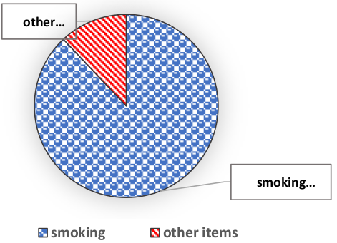

An image showing the distribution of lung cancer causes [9]

Symptoms used to diagnose lung cancer include yellow fingers, anxiety, chronic illness, fatigue, allergies, wheezing, coughing, coughing up blood (even small amounts), hoarseness, shortness of breath, bone pain, headache, difficulty swallowing, and chest pain [9].

### **2.1.2 Types of Lungs Cancer**

When it comes to the different types of lung cancer, the two main categories are small cell lung cancer (SCLC or small cell lung carcinoma) and non-small cell lung cancer (NSCLC or non-small cell lung carcinoma). These classifications are based on the appearance and behavior of the cancer cells under a microscope.

Non-Small Cell Lung Cancer (NSCLC) is the more common type, accounting for approximately 84% of all lung cancer cases. NSCLC encompasses several subtypes, including adenocarcinoma, squamous cell carcinoma, and large cell carcinoma. NSCLC tends to grow and spread more slowly than SCLC, but it can still be aggressive, especially in later stages. The overall 5-year survival rate for NSCLC is around 24%, with variations based on factors such as the stage at diagnosis and the patient's overall health [4].

On the other hand, Small Cell Lung Cancer (SCLC) is less common, making up about 16% of lung cancer cases. SCLC is characterized by small, oval-shaped cancer cells that multiply rapidly and have a high tendency to spread throughout the body. SCLC is strongly associated with smoking and is considered an aggressive form of lung cancer. The 5-year survival rate for SCLC is significantly lower than NSCLC, at around 6%.

Additionally, there are differences in survival rates between men and women diagnosed with lung cancer. According to statistics, the 5-year survival rate for women with lung cancer is approximately 23%, for men, it is around 16%. These disparities may be attributed to various factors, including differences in biology, smoking patterns, and access to healthcare [10].

The accurate and early detection of lung cancer, whether SCLC or NSCLC, is crucial for improving patient outcomes and enhancing survival rates. Computer-aided diagnosis (CAD) systems play an important role in this process by assisting radiologists in detecting and interpreting lung cancer from various imaging modalities, such as CT scans or X-rays. These CAD systems can provide a second opinion and potentially reduce the risk of missed or delayed diagnoses, ultimately improving the chances of successful treatment and recovery for patients.

To decide on the most appropriate treatment plan and optimize a patient's recovery rate, it is essential to diagnose lung cancer in its early stages, when it is more responsive to treatment and has a higher likelihood of being curable. Early diagnosis is particularly crucial for SCLC, given its aggressive nature and rapid progression.

For NSCLC, the 5-year survival rate is 24%, while for SCLC, it is around 6%. The survival rate for women with lung cancer is different from men, with 23% for women and 16% for men. Computer-aided diagnosis systems are used for the detection of lung cancer from image modalities, and they can also provide a second opinion for radiologists, which may enhance the survival rate of patients. To improve the patient's recovery rate and guide appropriate treatment decisions, lung cancer should be diagnosed in the early stages [11].

The accurate and timely detection of both types is essential for improving patient outcomes, and computer-aided diagnosis systems play a crucial role in assisting radiologists in this process, potentially enhancing survival rates for lung cancer patients.

### **2.1.3 Lung CT scan**

Computed Tomography (CT) scans have become an indispensable tool in the diagnosis and management of lung cancer. These advanced imaging techniques provide high-resolution, three-dimensional images of the lungs and surrounding structures, enabling radiologists to detect and characterize lung nodules, tumors, and other abnormalities with remarkable accuracy [12].

CT scans play a vital role in lung cancer screening, particularly for individuals at high risk, such as heavy smokers or those with a history of lung disease. By detecting lung cancers at an early stage, when they are often asymptomatic, CT screening can significantly improve the chances of successful treatment and survival. The National Lung Screening Trial, a large-scale study conducted in the United States, demonstrated that low-dose CT screening in high-risk individuals can reduce lung cancer mortality by approximately 20% compared to chest X-ray screening.

In addition to screening, CT scans are essential for the initial diagnosis of lung cancer. Once a suspicious nodule or lesion is identified, diagnostic CT scans can provide detailed information about the size, shape, location, and characteristics of the tumor. This information is crucial for determining the type and stage of lung cancer, which guides treatment decisions such as surgery, radiation therapy, chemotherapy, or a combination of these modalities [13].

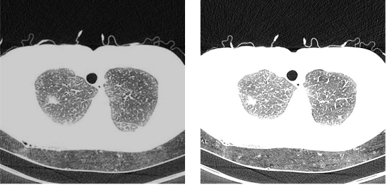

A CT scan of the human lungs [4]

CT scans offer several advantages over other imaging techniques in lung cancer diagnosis. They provide high-resolution, cross-sectional images that accurately depict the extent and spread of the tumor, as well as any involvement of nearby lymph nodes or metastases to other organs. This level of detail is essential for accurate staging, which is a critical factor in determining the most appropriate treatment approach.

Furthermore, CT scans can be combined with other imaging modalities, such as Positron Emission Tomography (PET), to create PET-CT scans. These hybrid scans provide both anatomical and functional information about the tumor, enhancing the diagnostic accuracy and treatment planning process [14].

### **2.1.4 Artificial Intelligence in Lung cancer detection**

The application of artificial intelligence (AI), particularly deep learning techniques such as convolutional neural networks (CNNs), has shown immense potential in revolutionizing lung cancer detection and diagnosis from radiological imaging data, including CT scans.

Deep learning, a subset of machine learning, involves training artificial neural networks with multiple layers to learn and extract complex patterns and features directly from raw data, such as medical images. CNNs are a type of deep neural network specifically designed for processing grid-like data, making them well-suited for image analysis tasks, including lung cancer detection from CT scans [15].

The key advantage of using CNNs for lung cancer detection is their ability to automatically learn and identify the subtle patterns and characteristics of lung nodules, tumors, and other abnormalities without the need for explicit feature engineering or human intervention. By training on large datasets of labeled CT scans, these models can learn to recognize the visual signatures of lung cancer with high accuracy, potentially surpassing the performance of human experts in certain tasks.

One of the primary applications of CNNs in lung cancer detection is the automated identification and classification of lung nodules from CT scans. These models can be trained to differentiate between benign and malignant nodules based on their size, shape, texture, and other visual characteristics, providing valuable decision support to radiologists in triaging suspicious lesions for further evaluation [16], [17], [18].

Additionally, CNNs can be employed for tasks such as tumor segmentation, where the model learns to delineate the boundaries of lung tumors within CT images accurately. This information can be crucial for treatment planning, such as determining the feasibility of surgical resection or radiation therapy targeting.

Furthermore, deep learning models can be trained to classify different types of lung cancer, such as non-small cell lung cancer (NSCLC) and small cell lung cancer (SCLC), based on the unique characteristics of the tumors observed in CT scans. This can aid in determining the appropriate treatment strategies and prognosis for patients [[19].

One of the key challenges in developing effective CNN-based models for lung cancer detection is the availability of large, high-quality, and accurately labeled datasets of CT scans. These datasets are essential for training the models and ensuring their generalizability to diverse patient populations and imaging conditions. Collaborative efforts among healthcare institutions, research organizations, and industry partners are crucial for curating and sharing these valuable datasets while ensuring patient privacy and data security.

Another challenge lies in the interpretability and trustworthiness of deep learning models, which are often perceived as "black boxes" due to their complexity. Researchers are actively exploring techniques to enhance the interpretability of CNNs, such as saliency maps and attention mechanisms, to provide insights into the decision-making process and build trust among clinicians and patients.

Despite these challenges, the integration of AI and deep learning techniques into lung cancer screening and diagnosis workflows holds immense promise. By automating and enhancing the detection and characterization of lung nodules and tumors, these technologies can potentially reduce diagnostic errors, improve consistency, and enable earlier intervention, ultimately leading to better patient outcomes and survival rates.

### **2.1.5 Convolutional Neural Network**

The use of Convolutional Neural Networks (CNNs) for detecting lung cancer is a significant application of deep learning in the medical field. CNNs are exceptionally suited for image analysis tasks because they can automatically learn features from images that are essential for classification. These networks have demonstrated effectiveness in medical imaging, proving to be a valuable tool for such tasks. They are especially well-suited for tasks that involve analyzing visual information, such as detecting diseases from medical images like X-rays, CT scans, MRIs, and more [[3].

Convolutional Neural Networks (CNNs) are designed to efficiently process and analyze visual information by leveraging several key features and layers. One of the significant advantages of CNNs is that the weights in the convolutional layer reduce the memory footprint and increase the network's performance.

The key feature of Convolutional Neural Network includes;

**1. 3D Volumes of Neurons:**

CNNs operate on 3D volumes of neurons, which allows them to capture spatial hierarchies in images.

**2. Local Connectivity:**

Each neuron in a convolutional layer is only connected to a local region of the input, enabling the network to focus on small, meaningful patches of the image.

**3. Shared Weights:**

Convolutional layers use a set of shared weights (or filters), which significantly reduces the number of parameters and computational load, improving efficiency and performance.

CNN has various layers, which all play a part in the detection and classification of images and data. They include [20];

**1. Convolutional Layer:** This layer applies a set of learned kernels (filters) to the input image, producing feature maps. Each filter convolves over different subregions of the input image to detect various features.

**2. ReLU Layer:** After convolution, a non-linear activation function such as ReLU (Rectified Linear Unit) is applied. This layer helps improve the network's convergence properties and introduces non-linearity.

**3. Pooling Layer:** Pooling layers perform down sampling operations, such as max pooling or average pooling. These operations reduce the dimensionality of the feature maps, helping to decrease the computational load and the risk of overfitting. For example, a 2x2 or 3x3 grid can be reduced to a single scalar value, significantly decreasing the sample size.

**4. Fully Connected (FC) Layer:** In later stages of the network, fully connected layers may be used to integrate features and make final predictions. These layers operate similarly to traditional neural networks, where each neuron is connected to every neuron in the previous layer.

## **2.2 Review of Related Literature**

**V. Sreeprada and Dr. K. Vedavathi** [3] utilized a Support Vector Machine (SVM) classifier to make estimations after constructing a nine-layer Convolutional Neural Network (CNN) to capture deep image information. The nine layers include an image input layer, two convolutional layers, two batch normalization layers, two pooling layers, a flattening layer, and a fully connected layer. The deep learning (DL) algorithms demonstrated the potential to outperform conventional machine learning (ML) models by learning from deep-layered and hierarchical data models, enabling rapid data processing. According to their findings, DL methods, such as auto-encoders, have been shown to effectively uncover the fundamental structure of data. CNNs are particularly popular for image categorization due to their ability to integrate the advantages of traditional neural network training with the convolution process, allowing for accurate image identification. The study also explored more systematic methods for lung cancer detection and investigated ways to mitigate the effects of downsampling, highlighting the effectiveness of the OCNN-SVM approach.

**Ibrahim M. Nasser and Samy S. Abu-Naser** [21] developed an Artificial Neural Network (ANN) to detect the presence or absence of lung cancer in the human body based on symptoms. They used a range of symptoms such as yellow fingers, anxiety, chronic disease, fatigue, allergy, wheezing, coughing, shortness of breath, swallowing difficulty, and chest pain as input variables for the ANN. Additional personal information was also incorporated. The ANN was established, trained, and validated using a dataset titled "survey lung cancer." Model evaluation demonstrated that the ANN could detect lung cancer with an accuracy of 96.67%.

**Akitoshi Shimazaki, Daiju Ueda, Antoine Choppin, Akira Yamamoto, Takashi Honjo, Yuki Shimahara, and Yukio Miki** [14] developed and validated a deep learning (DL)-based model using segmentation methods to detect lung cancer on chest radiographs. They collected chest radiographs separately for a training dataset and a test dataset from January 2006 to June 2018 at their hospital. The training dataset, consisting of 629 radiographs with 652 nodules/masses, was used to train and validate the DL-based model with five-fold cross-validation. The test dataset, comprising 151 radiographs with 159 nodules/masses, was employed to assess the model's sensitivity and mean false positive indications per image (mFPI). The results showed that the DL-based model achieved a sensitivity of 0.73 with 0.13 mFPI on the test dataset. Sensitivity was found to be lower for lung cancers overlapping with blind spots (0.50–0.64) such as pulmonary apices, pulmonary hila, chest wall, heart, and sub-diaphragmatic space, compared to non-overlapped locations (0.87). The dice coefficient for the 159 malignant lesions averaged 0.52. Overall, the DL-based model demonstrated the ability to detect lung cancers on chest radiographs with a low mFPI.

**Vinod Kumar, Chander Prabha, Preeti Sharma, Nitin Mittal, S. S. Askar, and Mohamed Abouhawwash** [6] have made significant strides in the field of machine learning for the early detection and prevention of lung cancer. Traditional research methods have struggled with the rapidly expanding volume of cancer-related information. To address this, the authors developed a support system utilizing three distinct deep-learning models: ResNet-50, EfficientNet-B3, and ResNet-101, incorporating transfer learning to enhance predictive capabilities. Their approach was tested on a dataset of 1,000 DICOM lung cancer images from the LIDC-IDRI repository, with each image categorized into four different classes. Their findings show substantial progress in the deep learning analysis of cancer data, which is crucial for improving health outcomes and reducing lung cancer mortality rates. Notably, the Fusion Model demonstrated 100% precision in classifying Squamous Cells, while both the Fusion Model and ResNet-50 achieved a 90% precision overall, with EfficientNet-B3 and ResNet-101 following closely. To mitigate overfitting and enhance data robustness, a data extension strategy was employed. This research not only highlights the potential of deep learning in cancer detection but also emphasizes the importance of precise accuracy in medical diagnoses, contributing to better health outcomes and lower mortality rates.

**Badireddygari Anurag Reddy and Danvir Mandal** [10] proposed a method for lung cancer cell identification through a series of image processing steps. The process begins with image preprocessing, where grayscale conversion is applied to medical images to simplify their format and remove hardware-level errors. Image segmentation and histogram equalization are then utilized to enhance contrast and clarity, improving the detection of features.

Thresholding techniques are employed to separate image data based on pixel intensity levels, aiding in segmentation and the extraction of relevant information. The authors observed that tumors in grayscale images typically fall within a specific pixel intensity range, facilitating their identification and isolation.

Feature extraction involves calculating various properties of identified objects, such as area, length, and eccentricity. MATLAB's regionprops function is used for this purpose, generating a matrix of extracted features to be fed into a neural network.

The detection system utilizes a backpropagation network with three layers: input, hidden, and output. The input layer corresponds to the extracted features, while the output layer distinguishes between malignant and benign cases. Binarization techniques are employed to classify color pixels into two classes, aiding in the identification of cancerous lungs.

MATLAB tools are utilized for network design and pattern recognition, with a Sigmoid training function employed for all layers. The network's performance is evaluated based on mean square error, with weights updated after each epoch until the minimum squared error is reached.

**Sneha S. Nair, V.N. Meena Devi, and Saju Bhasi** [12] proposed a comprehensive strategy for segmenting and classifying pulmonary nodules in lung CT scans. Their model consists of four main processes: pre-processing, nodule border extraction, feature extraction, and classification. They utilized an RWI (Random Walker Improved) technique for precise segmentation, aiming to locate the exact site of infection within input images. The classification methodology employs an Artificial Neural Network (ANN) using a Random Forest (RF) approach.

The authors employed the LIDC-IDRI dataset, containing a vast collection of lung images annotated with XML files, for model development and evaluation. Lung nodules in this dataset are categorized into five classes, distinguishing between benign and malignant nodules.

**Mattakoyya Aharonu and R Lokesh Kumar** [22] conducted a literature review focusing on the automatic detection of lung cancer, given its status as a leading cause of death globally. They highlighted the urgency of early detection, considering the significant number of new cases and deaths reported by the World Health Organization (WHO) in 2020. The proliferation of lung cells leads to malignant cancer, making early detection crucial for effective treatment.

The authors emphasized the role of technological advancements, particularly deep learning models like Convolutional Neural Networks (CNNs), in processing lung CT or MRI images for disease diagnosis. They underscored the importance of early-stage detection in improving treatment outcomes and curing the disease.

Their systematic review covered peer-reviewed journal papers and conference proceedings from 2012 to 2021, synthesizing various existing methods in machine learning (ML), deep learning, and artificial intelligence (AI) for lung cancer detection. The review provided insights into the strengths and weaknesses of different deep learning methods, identifying potential research gaps.

Overall, the paper aimed to enhance the reader's understanding of lung cancer detection methods and stimulate further research, particularly in developing models suitable for Clinical Decision Support Systems (CDSSs) required by healthcare units.

**Alakwaa, Nassef, and Badr** [23] developed a computer-aided diagnosis (CAD) system aimed at classifying lung cancer from CT scans featuring unmarked nodules. Their study utilized a dataset sourced from the Kaggle Data Science Bowl 2017. Initially, they employed thresholding for lung tissue segmentation from the CT scans, which yielded satisfactory results. However, direct application of 3D Convolutional Neural Networks (CNNs) for classification proved insufficient. Instead, they utilized a modified U-Net trained on LUNA16 data for nodule detection in Kaggle CT scans. Despite generating numerous false positives, this approach enabled identification of regions with potential nodules. Subsequently, these regions, along with segmented lung areas, were fed into 3D CNNs for final lung cancer classification. Their CAD system achieved a test set Accuracy of 86.6%, outperforming existing literature CAD systems. Notably, their system required only three major phases (segmentation, nodule candidate detection, and malignancy classification), demonstrating enhanced efficiency, generalizability, and reduced reliance on labeled data compared to traditional CAD systems.

**Karhan and Tunç** [24] conducted a study focusing on the detection of lung cancer utilizing blood values obtained from Ondokuz Mayıs University Department of Chest Diseases. The classification process involved evaluating the performance of various machine learning algorithms. Patient information, including age, hb, wbc, neu, lymph, plt, mpv, plr, and nlr, was utilized in the dataset. Prior to classification, the data underwent necessary normalizations. The study employed classification algorithms such as k-nearest neighbors, support vector machines, naive Bayes, artificial neural networks, and logistic regression. Accuracy rates, F-1 measure, precision, sensitivity, and specificity among classifiers were comparatively analyzed for lung cancer detection. The results indicated that support vector machines, neural networks, k-nearest neighbor, logistic regression, and naive Bayes algorithms exhibited the highest classification accuracy depending on the dataset.

**Asuntha, Brindha, Indirani, and Srinivasan** [25] explored the development of a lung cancer detection system leveraging image processing techniques. Their study aimed to create a versatile system capable of analyzing various medical image types, including CT, MRI, and ultrasound images. The proposed model utilized Particle Swarm Optimization (PSO), Genetic Optimization, and Support Vector Machine (SVM) algorithms for feature selection and classification. Building upon existing image processing methods for lung cancer detection, the study focused on feature extraction and selection following image segmentation. The system was designed to accept input from any of the three medical imaging modalities and applied preprocessing techniques, including edge detection using the Canny filter. Additionally, the study introduced a method for effectively detecting cancerous cells from CT, MRI, and ultrasound images, employing Superpixel Segmentation for segmentation and Gabor filtering for image denoising. Simulation results were obtained using MATLAB, and comparisons were drawn among the three medical imaging modalities to evaluate the effectiveness of the proposed cancer detection system.

**Parthasarathy G, Abirami S, Monica Santhana A, Nishali C, and Pavithrasrisai V** [26]conducted a study outlined in their methodology divided into several stages: Preprocessing, Activation Function Selection, Model Creation, Prediction, and Evaluation. The preprocessing stage involved data cleaning, integration, and outlier analysis. Activation functions were employed to transform input data before forwarding it to subsequent layers of neurons. The model creation phase utilized a deep learning network, where the dataset was analyzed, cross-validated, and then fed into the network to create and evaluate the model's performance.

The authors explored concepts in Artificial Intelligence (AI), including machine learning and artificial neural networks (ANN). They discussed the application of AI in various fields such as expert systems, speech recognition, and machine vision. Deep learning, a subset of machine learning, was highlighted for its ability to learn from unstructured data without explicit programming. Specifically, convolutional neural networks (CNNs) were introduced as a deep learning algorithm capable of processing input images, assigning importance to different aspects, and producing output. CNNs were noted for their effectiveness in diagnosing lung cancer, utilizing convolutional operations to capture spatial and temporal dependencies in images.

The study emphasized the advantages of CNNs, including their ability to reduce processing requirements and learn relevant filters or characteristics from training data. The architecture of CNNs was described as resembling the organization of neurons in the human brain's visual cortex, with neurons arranged in three dimensions (width, height, depth). The authors highlighted the role of activation functions, such as Rectified Linear Unit (ReLU) and sigmoid, in preprocessing input and generating output predictions.

In the prediction phase, the trained model was used to predict the dependent variable, and various evaluation measures, including Mean Absolute Error (MAE), Precision, Recall, and F1 score, were employed to assess the model's performance. The results indicated a classification accuracy of 90%, demonstrating the effectiveness of the proposed algorithm in diagnosing lung cancer.

**Pawar et al.** [27] conducted a comprehensive analysis of various models proposed by esteemed authors to address the issue of Lung Disease Diagnosis (LDD) using Computed Tomography (CT) and X-ray images. Their study focused on the versatility of Image Processing Techniques in developing superior models for detecting abnormalities in medical images.

The authors highlighted the multi-step process involved in image processing, including Image Acquisition, Enhancement, Segmentation, Feature Extraction, and Classification. They emphasized the significance of each step in accurately diagnosing lung diseases from medical images.

In their review, the authors discussed the importance of Image Segmentation, citing the thresholding technique introduced by Hu et al. and Otsu's method for determining global threshold values. Various feature extraction methods were explored, such as Histogram of Oriented Gradients (HOGs), statistical features, texture features, and value histograms.

Classification of tumors was identified as a critical stage, where classifiers like Support Vector Machine (SVM), K-nearest neighbors (K-NN), Decision trees, and Artificial Neural Networks (ANN) were commonly used. Performance evaluation of these classifiers was based on parameters like sensitivity, accuracy, and specificity.

The authors also provided insights into the challenges associated with classifier complexity, dataset size, and performance optimization. They compared established classification methods, highlighting their advantages and disadvantages.

**Guo et al.** [28] investigated the performance of a deep learning framework in automatically diagnosing pulmonary nodules at different count levels of PET imaging, aiming to lower FDG injecting for PET imaging. They utilized a 50-layer convolutional neural network (CNN) based on ResNet50 architecture, chosen for its ability to maintain accuracy with increased depth. The final fully connected layer was replaced with one having a single output and a sigmoid activation function. Binary cross entropy loss was optimized for each image, and nine predefined true count levels were obtained. Training, validation, and testing subsets were established, with image patches chosen by experienced physicians as ground truth. Data augmentation techniques were applied during training, and the network was initialized with pre-trained weights from ResNet50. Training was conducted using Adam optimizer with default parameters, and experiments were carried out using Keras with TensorFlow backend on an NVIDIA TITAN GTX GPU.

**S. Sasikala, M. Bharathi, B. R. Sowmiya** [20] conducted a study focused on lung cancer detection utilizing chest CT images employing Convolutional Neural Networks (CNN). Initially, lung regions were extracted from CT images, and each slice within those regions was segmented to identify tumors. These segmented tumor regions were utilized to train a CNN architecture, which was subsequently employed to test patient images. The primary objective was to detect whether tumors within a patient's lung were malignant or benign. The study demonstrated that the trained system could effectively identify cancerous presence in lung CT images.

The authors emphasized the significance of early lung cancer detection due to its high mortality rate, particularly in developing countries. Various imaging techniques, including Computed Tomography (CT), have been utilized for early detection. Despite numerous image processing techniques available, the accuracy of early cancer detection remains a challenge. To address this, machine learning techniques, particularly neural networks, have been increasingly employed. The study presented a CNN-based approach specifically designed to classify lung tumors as malignant or benign.

The dataset for training was obtained from the Lung Image Database Consortium (LIDC) and Image Database Resource Initiative (IDRI), comprising 1000 CT scans of tumors in DICOM format. Preprocessing involved the use of a median filter to minimize image degradation effects during acquisition

In the CNN architecture, convolutional layers and pooling layers were employed, with operations such as max pooling and mean pooling utilized to reduce the sample size while retaining important information. The architecture also included fully-connected layers towards the output stage.

Training the CNN involved the use of the back-propagation algorithm, with two phases: feature extraction and classification. Convolutional layers, rectified linear units (ReLU), and max pooling layers were used in the feature extraction phase, while fully-connected and threshold layers, followed by a SoftMax layer, were employed for classification.

## **2.3** **Chapter Summary**

Artificial intelligence can fundamentally alter how lung cancer patients are treated soon. Computer-aided strategies for identifying lung cancers have been generated by combining CT images to detect cancer, their segmentation, and their classification, which is faster and more accurate than human techniques. Many of the critical issues and efforts in the field of lung cancer diagnostics were covered in great depth in this chapter.

# **CHAPTER THREE**

# **SYSTEM ANALYSIS AND DESIGN**

## **3.1** **Chapter Introduction**

Early detection of lung cancer is crucial for improving patient outcomes, yet manual examination of computed tomography (CT) scan images by radiologists is time-consuming and prone to errors. This chapter presents the design of an automated lung cancer detection system that leverages advanced computer vision and machine learning techniques to analyse CT scan images and identify potential cancerous nodules with high accuracy.

The proposed system aims to enhance early lung cancer detection, improve diagnostic accuracy, streamline the workflow, and provide scalability to handle large volumes of data. Key components include data preprocessing, nodule detection and segmentation, feature extraction, and classification using machine learning models [29].

## **3.2** **Process Overview**

This section examines the individual modules involved in implementing the lung cancer detection web application, discussed in subsequent sections.

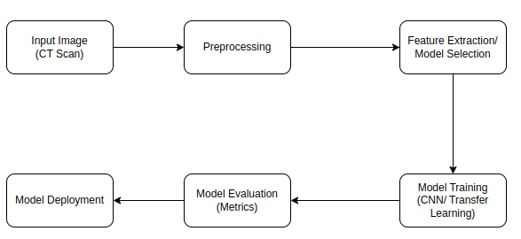

*Figure 3.1 The Lung cancer detection system*

1. **Input Image**: The dataset was obtained from Kaggle, a respected platform for data science that offers high-quality data for solving real-world issues and doing different machine learning tasks; this benefited the model’s training and execution.
2. **Preprocessing:** The dataset used was preprocessed in order for the model to have a better training and prediction accuracy, the images were improved with histogram-equalized.
3. **Feature Extraction:** Feature extraction is a crucial step in the process of transforming raw data into a format suitable for machine learning and other analytical tasks. It involves selecting and transforming relevant variables, or "features," from the data that can effectively represent the underlying patterns needed for modeling.
4. **Model Training**: Convolutional Neural Networks are constructed of layers that, when applied correctly, provide the best classification results. The implemented models were constructed using Python with the Jupyter Notebook interface and integrated with the TensorFlow, a machine learning and artificial intelligence framework.
5. **Evaluation of the model**: The models were evaluated to determine the accuracy with which they identify lung cancers from input CT images. In addition, specific metrics were investigated to see if the model is optimal.
6. **Model Deployment**: A web application was developed using the Streamlit library to make the model available to end-users.

## **3.3** **Design Requirements**

This section outlines the design criteria and guidelines used during the project’s development and implementation.

### **3.3.1 Functional Requirements**

The following comprises the services rendered by the lung cancer detection system, reactions to user inputs, and other behavioural patterns:

1. The application will support uploading multiple image formats (e.g., JPG, JPEG, or PNG).
2. Users should be able to upload images on both mobile devices and laptops.
3. The application should allow users to view the results.

### **3.3.2 Non-Functional Requirements**

The constraints of the system are highlighted below.

1. The system must deliver real-time and accurate cancer predictions.
2. The system must give timely predictions.
3. The information delivered by the system must be easy to comprehend.
4. The system should work on all devices with an internet connection and a web browser.
5. The system should be user-friendly.

## **3.4** **Architectural Overview**

The system follows a modular architectural design, consisting of data preprocessing, feature extraction, model training and evaluation, and deployment modules. Robust data preprocessing techniques enhance image quality and normalize the input data. Advanced feature extraction methods capture relevant characteristics from the CT scans.

The core of the system is a convolutional neural network (CNN) model trained on a large dataset of labelled CT images. The design evaluates the performance of various CNN architectures, including VGG16, VGG19, MobileNet, ResNet and Inception to identify the most suitable model for lung cancer detection.

### **3.4.1 Lung cancer CT Dataset**

The dataset was obtained from Kaggle library. The lung cancer dataset from the Iraq-Oncology Teaching Hospital/National Center for Cancer Diseases (IQ-OTH/NCCD) was gathered from these specialized hospitals over three months in the fall of 2019. It includes CT scans of lung cancer patients at various stages and healthy individuals. Oncologists and radiologists at these centers annotated the IQ-OTH/NCCD slides. The dataset comprises 1190 images from 110 cases, divided into three categories: normal, benign, and malignant. Out of these, 40 cases are malignant, 15 are benign, and 55 are normal. The CT scans were initially collected in DICOM format using a Siemens SOMATOM scanner. The CT protocol used included 120 kV, 1 mm slice thickness, window width from 350 to 1200 HU, and window center from 50 to 600 HU, with breath-hold at full inspiration. All images were anonymized before analysis, and the oversight review board waived the requirement for written consent. The study received approval from the institutional review board of the participating medical centers. Each scan consists of several slices, ranging from 80 to 200, each representing different views and angles of the human chest. The 110 cases vary in gender, age, educational background, area of residence, and living conditions. Participants include employees of the Iraqi ministries of Transport and Oil, as well as farmers and laborers, primarily from the central region of Iraq, especially Baghdad, Wasit, Diyala, Salahuddin, and Babylon provinces.

### **3.4.2 Data Pre-processing**

Histogram equalization is a technique used in image processing to improve the contrast of images. It enhances the image's visibility by effectively spreading out the most frequent intensity values, which results in an image with a more uniform histogram. This can be particularly useful in medical imaging, such as CT scans, where enhancing the visibility of features can aid in better diagnosis and analysis. Applying this technique as part of the preprocessing pipeline helped to improve the performance of machine learning models trained on these images.

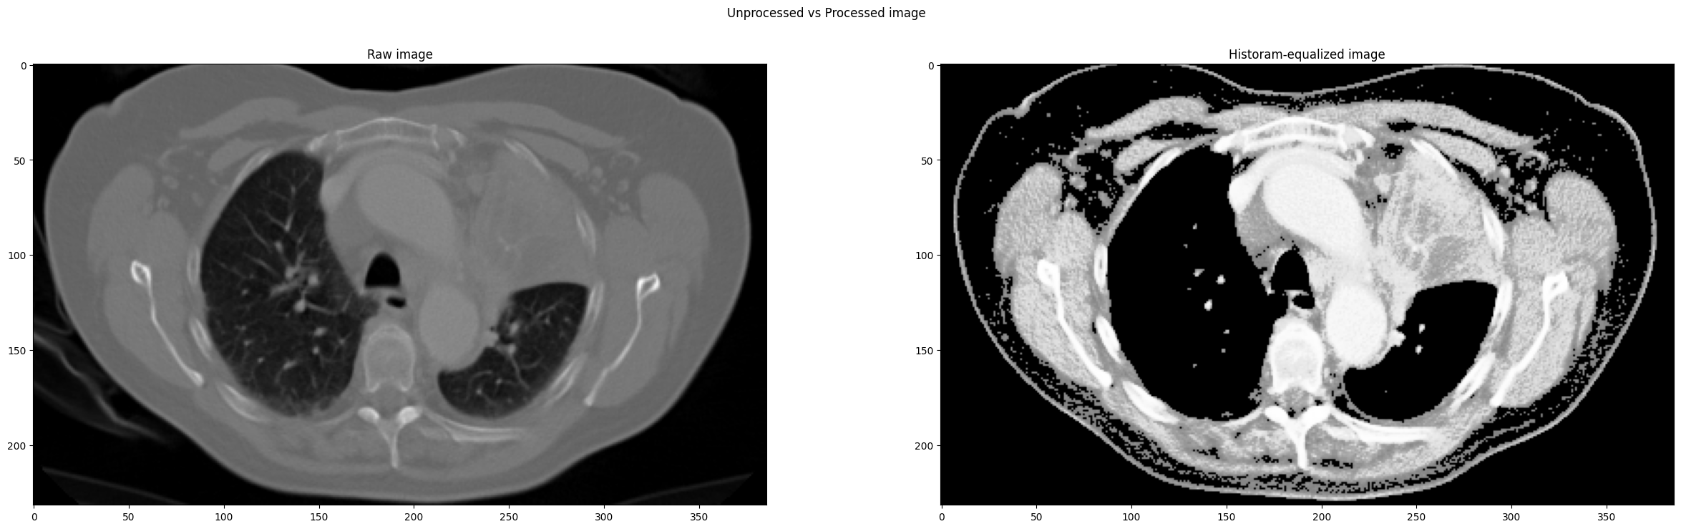

*Comparison of the raw image to histogram-equalized image*

Afterwards, a data generator was created, and given the image paths, it yielded the images with the respective labels as a batch.

### **3.4.3 CNN Layers Description**

Several layers make up the CNN architecture (or so-called multi-building blocks). Each model has its specific arrangement of layers and certain values that differentiate its performance outcomes. The layers in a CNN architecture include [30];

1. The **Convolutional Layer** includes several convolutional filters (kernels). These filters are convolved with the input picture to produce the output feature map. Conv2D is the layer representation.
2. **Pooling Layer**: This layer condenses huge feature maps into smaller ones. Simultaneously, it keeps most of the dominating information (or characteristics) in every stage of the pooling process. The layer representation is *MaxPooling2D*.
3. The **Fully Connected layer** was located after each network’s architecture. Each neuron in this layer is linked to all neurons from the previous layer and serves as the CNN classifier. A *Dense* layer is a traditional fully connected layer in which each input node is linked to each output case (in the systems case; four output nodes).
4. The **Batch Normalization Layer** guarantees that the output activations work correctly. It avoids the vanishing gradient problem, controls the wrong weight initialisation well, and considerably decreases the time required for huge datasets. The layer representation is *BatchNormalization*.
5. **Dropout Layer**: Neurons are lost at random throughout each training session. Dropout uniformly distributes the feature selection power over the whole set of neurons, pushing the model to pick up several distinct traits.
6. The **Flatten Layer** transforms the data into a one-dimensional array to feed into the next layer.
7. **Activation Functions** determine whether to release a neuron regarding a specific input by producing the relevant output. The implemented activation function is’ ReLU,’ and it transforms the absolute values of the input into positive integers. (The key advantage of ReLU over the others is its lower computing load).
8. **Loss Functions**: Loss functions are used in the output layer of the networks to compute the expected error produced over the dataset. Such error highlights the disparity between the actual and anticipated production. (The *Cross*-*Entropy* or *SoftMax* function was used to create the result within a probability distribution.)

### **3.4.4 CNN Architectures**

Four convolutional neural networks were employed: the AlexNet, ResNet152, MobileNetV2, and Xception. Their respective architectures are described as follows;

**1. VGG16 and VGG19**

VGG16 and VGG19 are deep convolutional networks known for their uniform and simple architecture, which makes them suitable for detailed image analysis, such as identifying cancerous nodules in lung CT scans.

**VGG16 Architecture:**

* **Convolutional Layers:** 13 convolutional layers using 3x3 filters, capturing fine-grained features of lung tissues.
* **Pooling Layers:** Max-pooling layers reduce the spatial dimensions while preserving important features.
* **Fully Connected Layers:** The final layers are fully connected, allowing for complex decision making based on the extracted features.

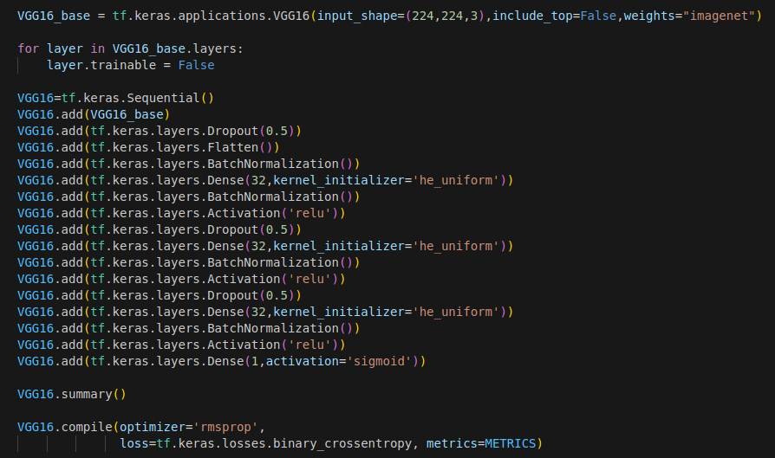

**VGG19 Architecture:**

* **Convolutional Layers**: 16 convolutional layers like VGG16, but with additional layers to capture more intricate details.
* **Pooling and Fully Connected Layers**: Like VGG16, facilitating deep feature extraction and classification.

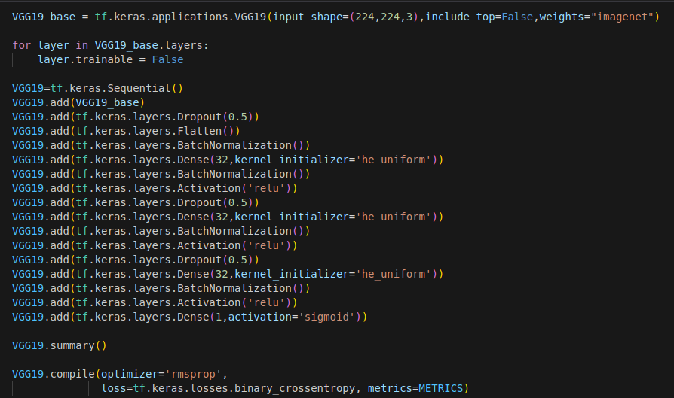These architectures can be fine-tuned on lung CT scan datasets to differentiate between cancerous and non-cancerous tissues.

**2. MobileNet**

MobileNet is optimized for efficiency, making it suitable for real-time lung cancer detection on resource-constrained devices, such as portable medical devices used in remote areas.

**Architecture:**

* **Depthwise Separable Convolutions**: Efficiently capture essential features of lung tissues with reduced computational load.
* **Global Average Pooling**: Summarizes the features before the final classification layer, suitable for distinguishing between normal and abnormal lung scans.

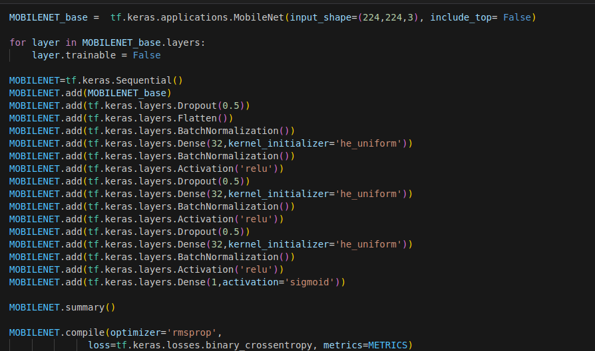MobileNet's lightweight nature ensures it can be deployed in mobile healthcare applications, providing accessible lung cancer screening.

**3. ResNet (Residual Networks)**

ResNet is capable of training very deep networks, which is beneficial for capturing complex patterns in lung CT scans indicative of cancer.

**Architecture:**

* **Residual Blocks**: Allow for deep network training by using skip connections, essential for learning intricate lung tissue structures.
* **Layers**: Depending on the variant (e.g., ResNet-50, ResNet-101), the network can go very deep, capturing detailed features across different layers.

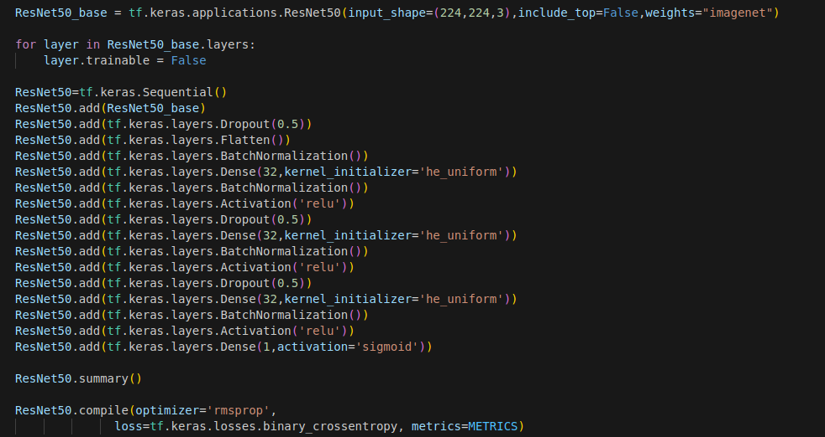ResNet's ability to train deep networks without performance degradation makes it ideal for accurately identifying early signs of lung cancer in CT scans.

**4. Xception**

Xception leverages depthwise separable convolutions for efficient feature extraction, making it suitable for detailed image analysis required in lung cancer detection.

**Architecture:**

* **Entry, Middle, and Exit Flow**: Structured into these flows, it effectively captures features at various levels of abstraction.
* **Depthwise Separable Convolutions**: Enhance the ability to learn fine details of lung tissues, crucial for detecting small nodules.

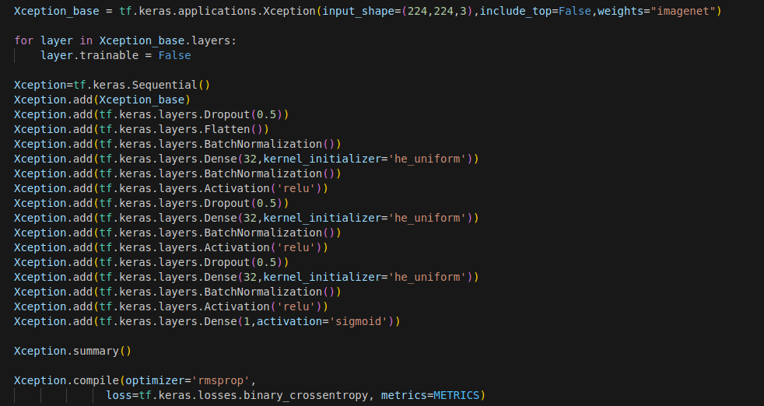

Xception's architecture is well-suited for high-resolution lung CT scans, providing detailed analysis and accurate classification.

### **3.4.5 Training and Testing**

Specific parameters were considered for correct predictions when training to attain an accurate model. The section highlights the functions and specifications of the parameters implemented in each model.

1. **Optimiser**: An optimiser’s function is to alter model weights to maximise a loss function. The rmsprops optimiser was used.
2. **Learning Rate**: This hyperparameter describes how much the model should adjust each time the weights are updated to account for the expected inaccuracy. The adopted learning rate used was 0.0001.
3. **Loss**: The loss is a number that indicates how incorrect the model’s forecast was on a particular example. The loss used was the ‘crossentropy.’
4. **Metrics**: During the training stage, metrics improve the classification algorithm. The metric used was Accuracy, Recall, Precision and AUC.  
   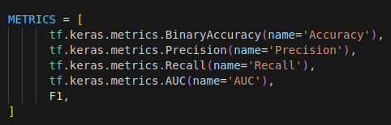
5. **Batch size** is a gradient descent hyperparameter that regulates the number of training samples to go through before updating the internal parameters of the network. The batch size was set to 32.
6. **Epochs**: The parameter update is conducted once utilizing all of the training data throughout the training period. The number of epochs set was 10.

### **3.4.6 Web Application**

The web application receives a CT scan image uploaded by the user and classifies the image into cancerous or non-cancerous. The supported image formats are PNG, JPG, and JPEG. The significant functionality implemented in the web application involves:

1. Loading the trained model
2. Resizing the image and converting to RGB format
3. The normalisation of the images, then reshaping.
4. Predict image class and display result.

## **3.6** **Chapter Summary**

This chapter presents the design of an automated lung cancer detection system that utilizes advanced computer vision and deep learning techniques to analyse CT scan images and accurately identify cancerous lung nodules. The system architecture comprises modules for data preprocessing, feature extraction, model training and evaluation, and deployment considerations.

# **CHAPTER FOUR**

# **RESULTS AND DISCUSSION**

## **4.1** **Chapter Introduction**

This chapter presents and discusses the project findings concerning the project’s objective, which is to design and implement a web application for brain tumour classification. The degree to which the web application provides accurate predictions and the influence of varying the exact training settings used to generate the various CNNs is highlighted.

## **4.2** **Discussion**

The model results provide valuable insights into the performance of different CNN architectures for lung cancer detection.

VGG16 demonstrates impressive performance across all metrics, with high accuracy, precision, recall, and AUC. MobileNet achieves excellent results, especially in terms of recall and AUC, indicating its ability to effectively detect lung cancer while minimizing false negatives. Xception delivers strong performance across all metrics, with high accuracy, precision, recall, and AUC. VGG19 and ResNet also perform well but show slightly lower recall, indicating potential challenges in correctly identifying all instances of lung cancer. Overall, MobileNet stands out for its excellent balance between recall, precision, and AUC, making it a promising choice for lung cancer detection applications.

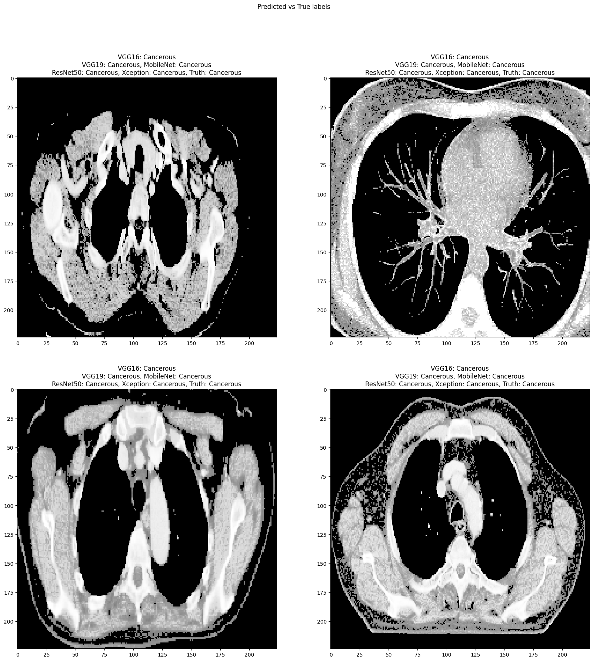

### **4.2.1 Accuracy and Loss Graph**

Accuracy and loss graphs are essential tools for monitoring the performance and training dynamics of CNN models, particularly in lung cancer detection. The accuracy graph tracks the model's performance on both training and validation datasets over epochs, while the loss graph illustrates the model's loss during training. Ideally, accuracy should increase, and loss should decrease over epochs, indicating effective learning. Fluctuations or divergences between training and validation metrics may indicate issues like overfitting or poor convergence, necessitating adjustments in model architecture or training strategies. Regular monitoring of these graphs allows for timely optimization of model performance, ensuring robustness in real-world applications. Below are the graphs for the various models;

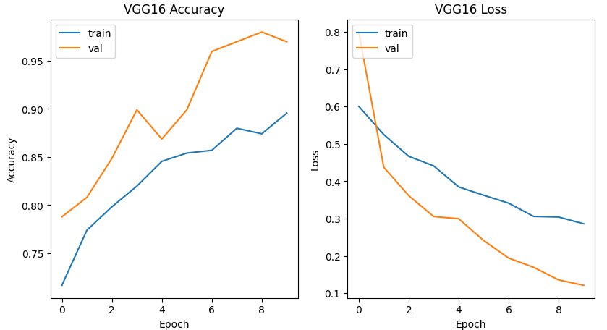

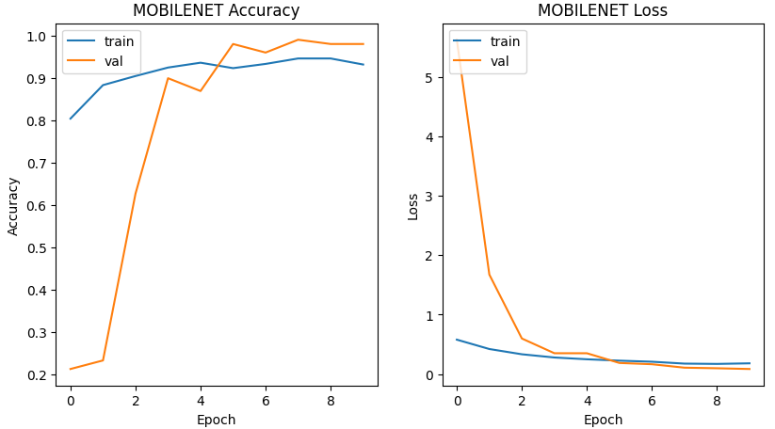

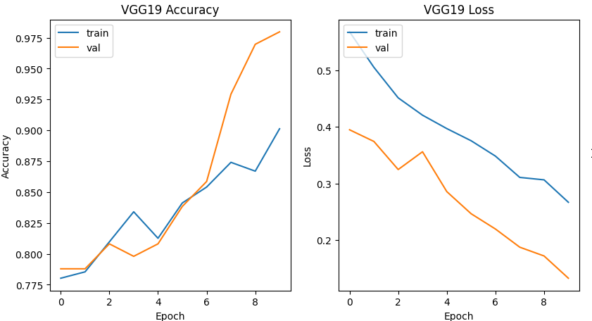

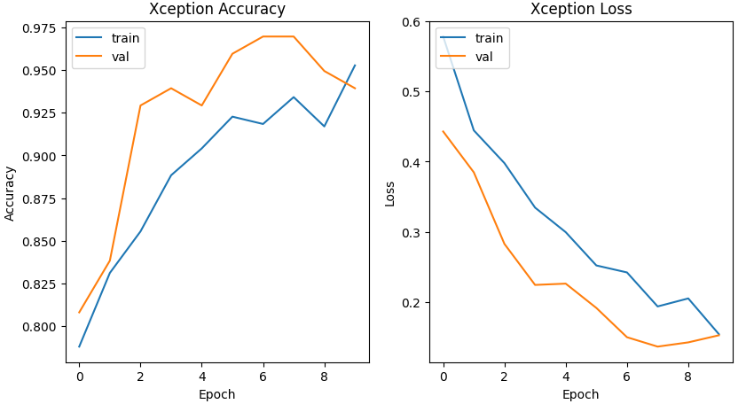

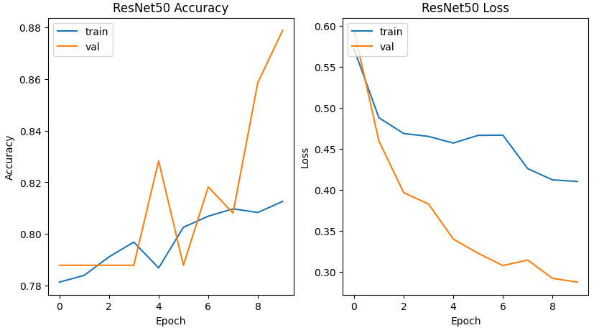

### **4.2.2 Confusion Matrix**

A confusion matrix is a summary table that shows the model's performance by comparing its predictions to the actual class labels. It consists of four components: True Positive, True Negative, False Positive, and False Negative. From these values, performance metrics like accuracy, precision, recall, and F1-score can be derived, providing insights into the model's classification performance.

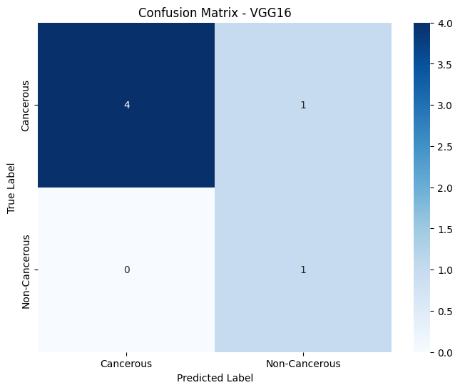

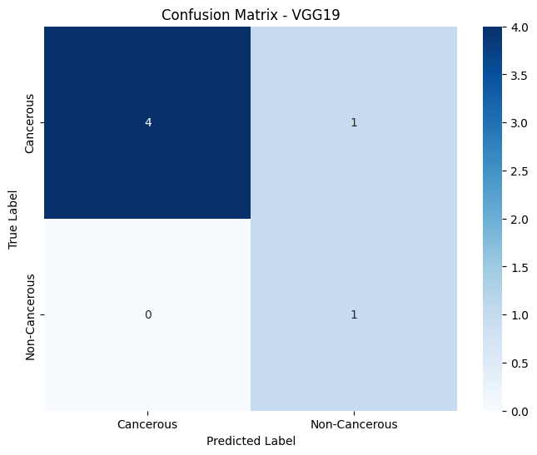

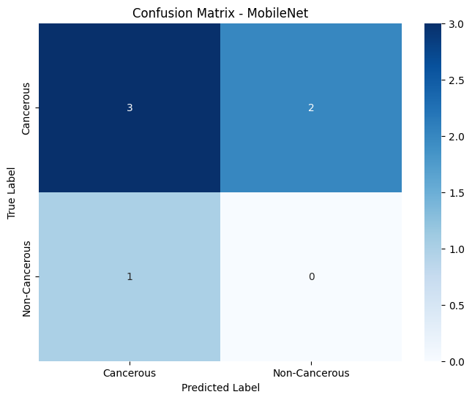

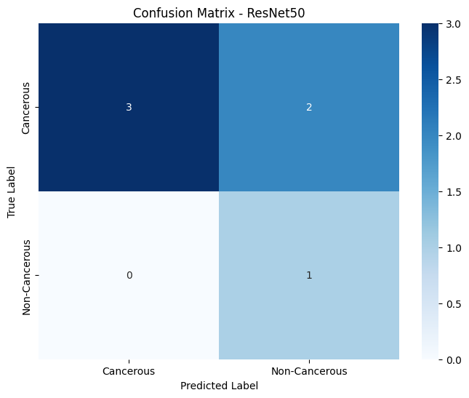

### **4.2.3 Classification Report**

A classification report provides a brief overview of the performance metrics for a classification model. It includes metrics like Accuracy, precision, recall, F1-score, and support for each class. Precision gauges the ratio of true positive predictions among all positive predictions, while recall measures the ratio of true positive predictions among all actual positive instances. The F1-score offers a balanced evaluation of a model's performance, being the harmonic means of precision and recall. Furthermore, the support metric indicates the frequency of each class in the dataset. By analyzing the classification report, stakeholders can grasp a comprehensive understanding of how well the model correctly classifies instances across various classes.

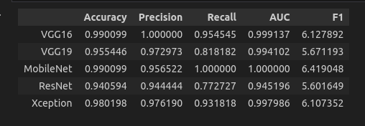

### **4.2.4 Web Application Interface**

The web application, built using Streamlit, provides an intuitive interface for accessing and utilizing machine learning models. Streamlit simplifies development by enabling seamless integration of models and user input elements, allowing for easy experimentation and exploration of predictions.

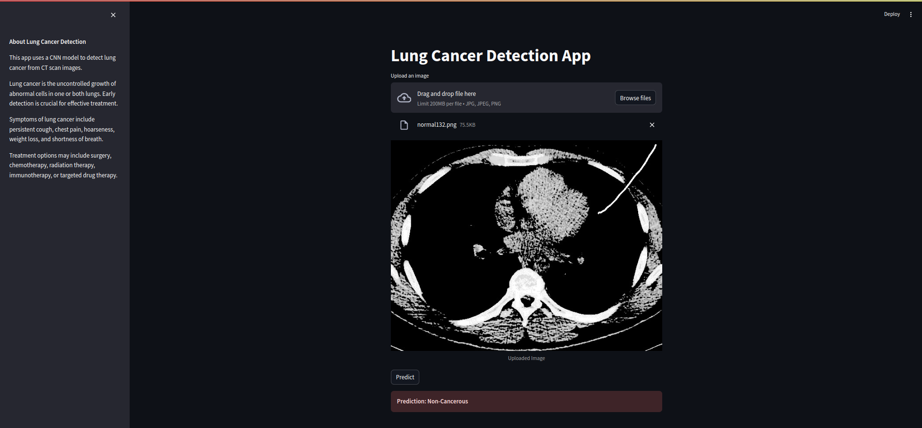

## **4.3** **Chapter Summary**

This chapter explored the performance evaluation of CNN models for lung cancer detection, analyzing results from architectures like VGG16, VGG19, MobileNet, ResNet, and Xception. MobileNet exhibited exceptional balance in metrics like recall, precision, and AUC. Additionally, the chapter emphasized the importance of accuracy and loss graphs for monitoring training progress. These visualizations help identify issues like overfitting or poor convergence, allowing for timely adjustments to optimize model performance. Overall, the chapter highlighted the significance of thorough evaluation and continuous monitoring to enhance CNN-based diagnostic tools for improved patient care in medical imaging.

# **CHAPTER FIVE**

# **CONCLUSION**

## **5.1** **Chapter Introduction**

This concluding chapter presents a summary of the investigation into CNN architectures for lung cancer detection. The assessment of various models based on metrics like accuracy, precision, recall, AUC, and F1 score has provided insights into their potential for transforming lung cancer diagnosis. This chapter aims to distil the essence of the study and chart a path forward towards leveraging artificial intelligence for improved patient care in lung cancer detection.

## **5.2** **Summary**

In conclusion, the evaluation of CNN architectures for lung cancer detection reveals promising prospects for improving diagnostic accuracy and patient outcomes in medical imaging. Among the architectures assessed, MobileNet demonstrates notable performance, showcasing a fine balance between key metrics such as recall, precision, and AUC. The significance of accuracy and loss graphs in monitoring training dynamics cannot be overstated, as these visualizations enable timely adjustments to optimize model performance and address issues like overfitting or poor convergence.

Moving forward, continued research and development in CNN-based diagnostic tools hold the potential to revolutionize lung cancer detection and diagnosis. By leveraging advancements in machine learning and medical imaging technology, practitioners can enhance the efficiency and reliability of screening processes, leading to earlier detection, timely intervention, and improved treatment outcomes for patients.

Furthermore, the success of CNN models in lung cancer detection underscores the broader applicability of deep learning techniques in healthcare. As these models continue to evolve and integrate with clinical practice, they have the potential to transform various aspects of medical diagnosis, treatment planning, and patient care across diverse medical specialties.

In essence, the evaluation of CNN architectures for lung cancer detection represents a crucial step towards harnessing the power of artificial intelligence to enhance healthcare delivery, improve patient outcomes, and ultimately save lives.

## **5.3** **Recommendations**

Further refine the CNN architectures based on the distinct features of lung cancer CT scan images to enhance model effectiveness and adaptability. Explore ensemble learning methods to amalgamate predictions from multiple CNN models, potentially bolstering overall accuracy and resilience. Examine the incorporation of domain-specific expertise, such as radiological knowledge or clinical insights, into the CNN models to improve their interpretability and diagnostic precision. Collaborate closely with healthcare practitioners and radiologists to acquire additional annotated data and validate the CNN models across varied patient demographics and disease types, ensuring their reliability and applicability. Investigate the implementation of CNN-based diagnostic tools in clinical environments, ensuring smooth integration into existing processes and adherence to regulatory requirements for medical devices. Continually monitor and refine the CNN models with new data and advancements in deep learning methodologies to remain at the forefront of lung cancer detection research and technological advancements. Foster interdisciplinary collaboration with clinicians, researchers, data scientists, and industry stakeholders to harness diverse expertise and resources for advancing CNN-driven diagnostic solutions for lung cancer detection.

# **Reference**

[1] J. Kim, H. Lee, and B. W. Huang, “Lung Cancer: Diagnosis, Treatment Principles, and Screening,” 2022. [Online]. Available: www.aafp.org/afpAmericanFamilyPhysician487

[2] J. Hana and N. N. Faizah, “Diagnostic Approach of Lung Cancer: A Literature Review,” *Jurnal Respirasi*, vol. 9, no. 2, pp. 141–149, May 2023, doi: 10.20473/jr.v9-i.2.2023.141-149.

[3] V. Sreeprada and K. Vedavathi, “Lung Cancer Detection from X-Ray Images using Hybrid Deep Learning Technique,” in *Procedia Computer Science*, Elsevier B.V., 2023, pp. 467–474. doi: 10.1016/j.procs.2023.12.102.

[4] J. M. N. Prasad, S. Chakravarty, and M. V. Krishna, “Lung cancer detection using an integration of fuzzy K-means clustering and deep learning techniques for CT lung images,” *Bulletin of the Polish Academy of Sciences: Technical Sciences*, vol. 70, no. 3, 2022, doi: 10.24425/bpasts.2021.139006.

[5] M. A. Thanoon, M. A. Zulkifley, M. A. A. Mohd Zainuri, and S. R. Abdani, “A Review of Deep Learning Techniques for Lung Cancer Screening and Diagnosis Based on CT Images,” *Diagnostics*, vol. 13, no. 16. Multidisciplinary Digital Publishing Institute (MDPI), Aug. 01, 2023. doi: 10.3390/diagnostics13162617.

[6] V. Kumar, C. Prabha, P. Sharma, N. Mittal, S. S. Askar, and M. Abouhawwash, “Unified deep learning models for enhanced lung cancer prediction with ResNet-50–101 and EfficientNet-B3 using DICOM images,” *BMC Med Imaging*, vol. 24, no. 1, Dec. 2024, doi: 10.1186/s12880-024-01241-4.

[7] C. Shankara and S. A. Hariprasad, “Artificial neural network for lung cancer detection using CT images,” *Int J Health Sci (Qassim)*, pp. 2708–2724, Apr. 2022, doi: 10.53730/ijhs.v6ns2.5639.

[8] M. R. Hasan, M. Al Kabir, and R. Hasan, “Lung Cancer Detection and Classification based on Image Processing and Statistical Learning,” *Journal of Emerging Trends in Engineering and Applied Sciences*, no. 6, p. 11.

[9] H. Hosseini, R. Monsefi, and S. Shadroo, “Deep Learning Applications for Lung Cancer Diagnosis: A systematic review.”

[10] B. A. Reddy and D. Mandal, “Detection of Lung cancer using Digital image Processing techniques and Artificial Neural Networks,” in *Journal of Physics: Conference Series*, Institute of Physics, 2022. doi: 10.1088/1742-6596/2327/1/012078.

[11] Maciej Serda *et al.*, “Synteza i aktywność biologiczna nowych analogów tiosemikarbazonowych chelatorów żelaza,” *Uniwersytet śląski*, vol. 7, no. 1, pp. 343–354, 2013, doi: 10.2/JQUERY.MIN.JS.

[12] S. S. Nair, V. N. M. Devi, and S. Bhasi, “Enhanced lung cancer detection: Integrating improved random walker segmentation with artificial neural network and random forest classifier,” *Heliyon*, vol. 10, no. 7, Apr. 2024, doi: 10.1016/j.heliyon.2024.e29032.

[13] N. Chaudhari and D. A. V Malviya, “IMAGE PROCESSING FOR DETECTION OF LUNG CANCER: A REVIEW,” 2021. [Online]. Available: www.ijcrt.org

[14] A. Shimazaki *et al.*, “Deep learning-based algorithm for lung cancer detection on chest radiographs using the segmentation method,” *Sci Rep*, vol. 12, no. 1, Dec. 2022, doi: 10.1038/s41598-021-04667-w.

[15] R. P. Ram Kumar, S. Polepaka, D. Likithasree, and S. Keerthika, “An Investigation on CNN-based Lung Cancer Prediction Method,” *2023 International Conference on Computer Communication and Informatics, ICCCI 2023*, 2023, doi: 10.1109/ICCCI56745.2023.10128379.

[16] S. Makaju, P. W. C. Prasad, A. Alsadoon, A. K. Singh, and A. Elchouemi, “Lung Cancer Detection using CT Scan Images,” in *Procedia Computer Science*, Elsevier B.V., 2018, pp. 107–114. doi: 10.1016/j.procs.2017.12.016.

[17] H. Jung, B. Kim, I. Lee, J. Lee, and J. Kang, “Classification of lung nodules in CT scans using three-dimensional deep convolutional neural networks with a checkpoint ensemble method,” *BMC Med Imaging*, vol. 18, no. 1, Dec. 2018, doi: 10.1186/s12880-018-0286-0.

[18] B. Abdillah, A. Bustamam, and D. Sarwinda, “Image processing based detection of lung cancer on CT scan images,” in *Journal of Physics: Conference Series*, Institute of Physics Publishing, Oct. 2017. doi: 10.1088/1742-6596/893/1/012063.

[19] “Lung Cancer Detection Using Deep Learning,” *international journal of food and nutritional sciences*, vol. 11, no. 12, Apr. 2023, doi: 10.48047/ijfans/v11/i12/189.

[20] S. Sasikala, M. Bharathi, and B. R. Sowmiya, “Lung Cancer Detection and Classification Using Deep CNN.”

[21] I. M. Nasser and S. S. Abu-Naser, “Lung Cancer Detection Using Artificial Neural Network,” 2019. [Online]. Available: www.ijeais.org

[22] M. Aharonu and R. Lokesh Kumar, “Systematic Review of Deep Learning Techniques for Lung Cancer Detection.” [Online]. Available: www.ijacsa.thesai.org

[23] W. Alakwaa, M. Nassef, and A. Badr, “Lung Cancer Detection and Classification with 3D Convolutional Neural Network (3D-CNN),” 2017. [Online]. Available: www.ijacsa.thesai.org

[24] Z. Karhan and T. Tunç, “Lung Cancer Detection and Classification with Classification Algorithms,” vol. 18, no. 6, pp. 71–77, doi: 10.9790/0661-1806037177.

[25] A. Asuntha and A. Srinivasan, “Deep learning for lung Cancer detection and classification,” *Multimed Tools Appl*, vol. 79, no. 11–12, pp. 7731–7762, Mar. 2020, doi: 10.1007/S11042-019-08394-3.

[26] M. A. Santhana, “PREDICTION OF LUNG CANCER USING DEEP LEARNING ALGORITHM,” 2020. [Online]. Available: www.ijcrt.org

[27] V. J. Pawar, “Lung Cancer Detection System Using Image Processing and Machine Learning Techniques,” *International Journal of Advanced Trends in Computer Science and Engineering*, vol. 9, no. 4, pp. 5956–5963, Aug. 2020, doi: 10.30534/ijatcse/2020/260942020.

[28] Y. Xu *et al.*, “Investigation of small lung lesion detection for lung cancer screening in low dose FDG PET imaging by deep neural networks.”

[29] J. Mendoza, H. P.-C. Intelligence, and undefined 2020, “Detection and classification of lung nodules in chest X‐ray images using deep convolutional neural networks,” *Wiley Online Library*, Accessed: Feb. 04, 2024. [Online]. Available: <https://onlinelibrary.wiley.com/doi/abs/10.1111/coin.12241>

[30] “Detection and classification of lung cancer using CNN and Google net - ScienceDirect.” Accessed: Dec. 04, 2023. [Online]. Available: <https://www.sciencedirect.com/science/article/pii/S2665917422002227#bib13>